**CURRICULUM VITAE** 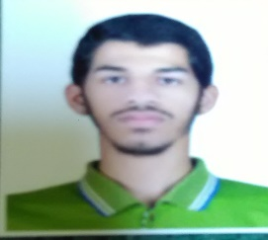

**HUSAIN ALI SALMAN AHMED**

**Hussaingazal534@GMIL.COM**

|  |  |  |
| --- | --- | --- |
| **Personal Details** | | |
|  | Name  Nationality  Date of Birth  CPR No.  Address  Marital Status  Contact Number | : Husain ali Salman  : Bahraini  : 01/02/1998  : 980200016  : flat/villa0bldg#1022road:536rd name:r536/536block#605block:murqoban  : Single  : +973 38210477 |

**OBJECTIVE**

* A position where I can utilize proven people-oriented skills to develop, contribute and promote a positive work environment.

**EDUCATIONAL ATTAINMENT**

* Study in al taween secondary school. 2013-2016
* Good Computer knowledge

**GENERAL SKILLS**

* Good in problem solving and a fast learner of new technologies.
* Passion for work, always trying to improve on performance
* Good knowledge in computer

**LANGUAGES SPOKEN**

* Arabic ( Native Language)
* English (Good)